***GIT Branching***

**Q2**

Objective: Commit HTML, CSS & JavaScript assignments into GIT.

SECTION-1 (HTML assignments) - Steps to follow:

21. First take a backup of your assignments & projects. This is required because due to incorrect GIT operation you may lose your files.

22. Create an empty directory ‘Assignments’ & cd to ‘Assignments’.

23. Create a file README.txt inside ‘Assignments’ & write few lines about the contents of ‘Assignments’ folder.

24. Commit README.txt file.

25. Now create a new branch ‘html-assignments’.

26. Switch to ‘html-assignments’ branch.

27. Copy all HTML assignments inside ‘Assignments’ folder.

28. Commit HTML assignments into ‘html-assignments’ branch.

29. Make minor changes into few files belonging to ‘html-assignments’ branch.

30. Commit those changed files.

31. Switch to master branch.

32. Make minor changes into README.txt file & commit those changes into master.

33. Again switch to ‘html-assignments’ branch.

34. Make minor changes into few files belonging to ‘html-assignments’ branch.

35. Commit those changes.

36. Switch to master.

37. Merge ‘html-assignments’ branch into master. Confirm all html assignments are shown in master.

38. Finally delete the ‘html-assignments’ branch.

SECTION-2 - (CSS assignments) Steps to follow:

1. Create a new branch ‘css-assignments’.

2. Switch to ‘css-assignments’ branch.

3. Copy all CSS assignments inside ‘Assignments’ folder.

4. Commit CSS assignments into ‘css-assignments’ branch.

5. Make minor changes into README.txt file on line 1 belonging to ‘css-assignments’ branch.

6. Commit those changed files.

7. Switch to master branch.

8. Make minor changes into README.txt file on line 3 & commit those changes into master.

9. Again switch to ‘css-assignments’ branch.

10. Make minor changes into few files belonging to ‘css-assignments’ branch.

11. Commit those changes.

12. Switch to master.

13. Merge ‘css-assignments’ branch into master. Confirm all css assignments are shown in master.

14. Finally delete the ‘css-assignments’ branch.

SECTION-3 - (JavaScript assignments) Steps to follow:

1. Create a new branch ‘js-assignments’.

2. Switch to ‘js-assignments’ branch.

3. Copy all JavaScript assignments inside ‘Assignments’ folder.

4. Commit JavaScript assignments into ‘js-assignments’ branch.

5. Make minor changes into README.txt file on line 1 belonging to ‘js-assignments’ branch.

6. Commit those changed files.

7. Switch to master branch.

8. Make minor changes into README.txt file on line 1 & commit those changes into master.

9. Again switch to ‘js-assignments’ branch.

10. Make minor changes into few files belonging to ‘js-assignments’ branch.

11. Commit those changes.

12. Switch to master.

13. Merge ‘js-assignments’ branch into master. Confirm all JavaScript assignments are shown in master.

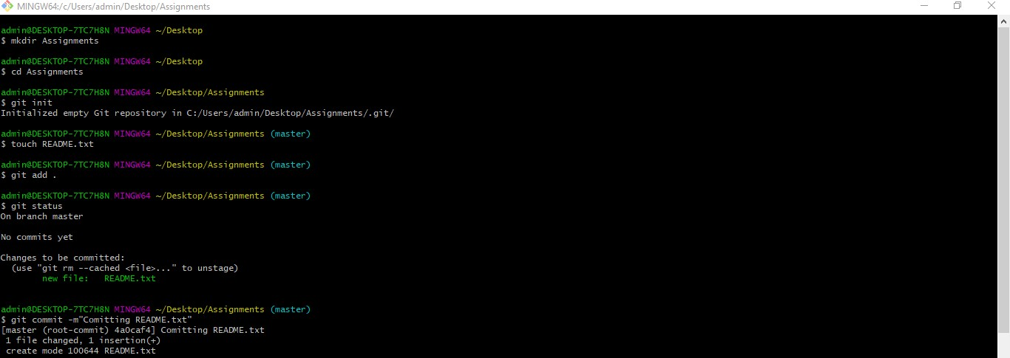14. Finally delete the ‘js-assignments’ branch.

